**Project Report Template**

1. Introduction:
   1. Overview

Project topic: India’s agriculture crop production.

Agriculture plays a vital role in the Indian economy. Over 70 per cent of the rural households depend on agriculture.

Agriculture is an important sector of Indian economy as it contributes about 17% to the total GDP and provides employment to over 60% of the population.

Major crops grown in India are Rice, Wheat, Millet, Pulses, tea, coffee, sugarcane, etc,.

In this project, 1st we create Empathy map, Brainstorming, next we collect the dataset and the dataset is apply in tableau app, next we create 9 Sheets, 3 Dashboard, 2 Stories on tableau.

In this project, 9 Sheets are described on State production, Season based cultivation, Yield by season, Crop plantation by area such as rice, wheat, etc., Major crops year wise Bar chart, Crop plantation by count, Season wise production in pie chart. We created this in the dataset about India’s agriculture crop production.

* 1. Purpose

The use of the project:

* Better decision making for better probability
* Cleaner understanding of this dataset provides a huge amount of information on crop production in India ranging from several years.
* Easy go understand the dataset.
* Easy to solve the Indian agriculture problem.

What can be achieved?

Big data provides farmer granular data on rainfall patterns, water cycle, fertilizers, requirements and more.

2. Problem Definition and Design Thinking

* 1. Empathy map

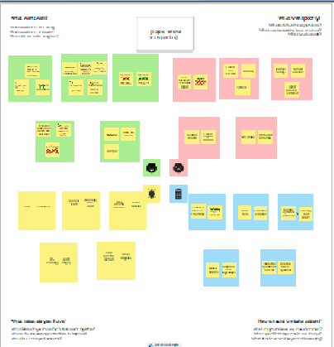

* 1. Ideation & Brainstorming Map

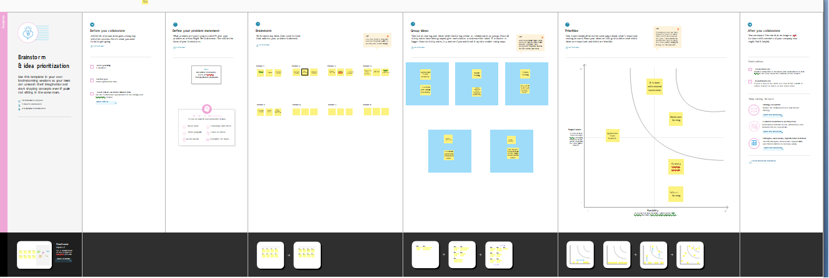

3. Result:

1. Area vs Production
2. Crop Production by area
3. Major crops
4. Statewise Production

1. 2. 3. 4. 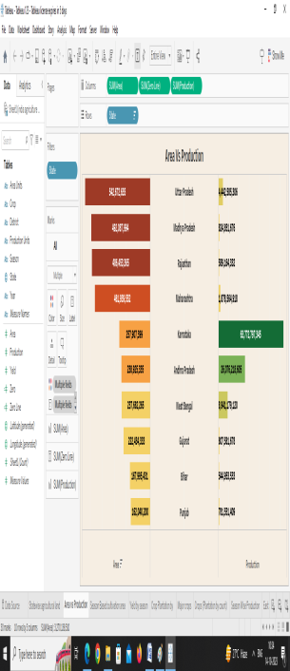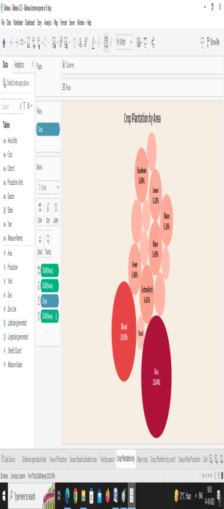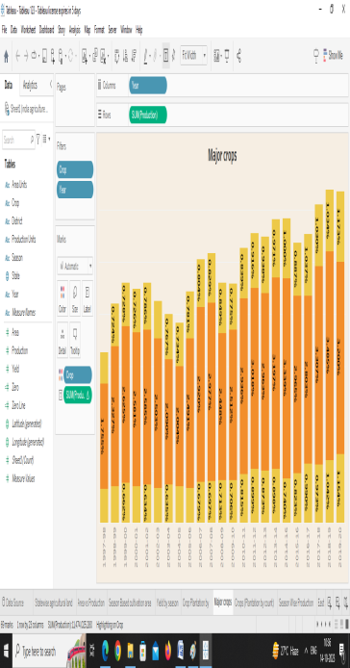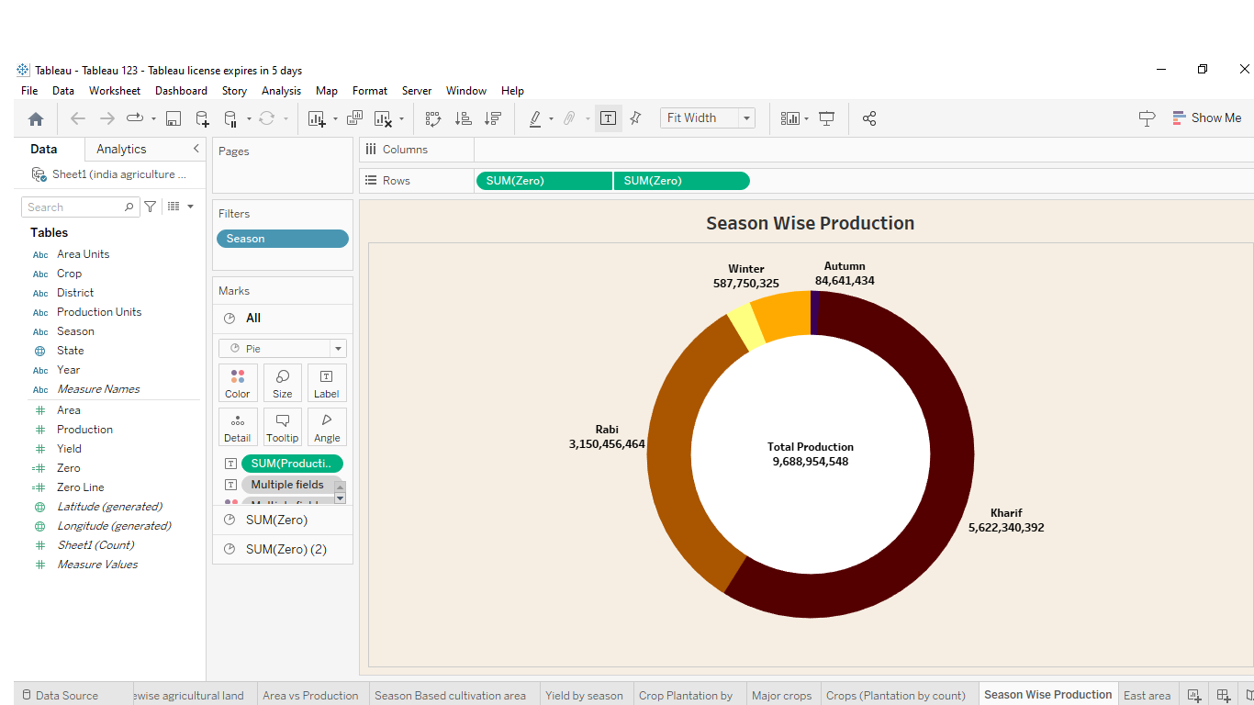

4. Advantages and Disadvantages:

Advantages

* Its have clear solution.
* The data can be used to agricultural people to analyze which season and crop are grown & how will overcome the agricultural problem.

Disadvantage

* Its have large data.

5. Applications

* In this project about agricultural data is information related to farming including information on growing crops, managing land and monitoring weather patterns .
* This information can help both investor and agricultural companies in their decision making & more.

6. Conclusion:

In the above report we saw the project overview, purpose & problem definition and design, advantages and disadvantages, application.

7. Future scope:

In the agriculture field, the global population is expected to reach nearly 10 billion by 2050, which means that there will be a significant increase in demand for food.